Aashuli Anil Gupta

**AWS MASTERCLASS**

PART1: AWS

1.AWS LOGIN SCREEN WITH USERNAME

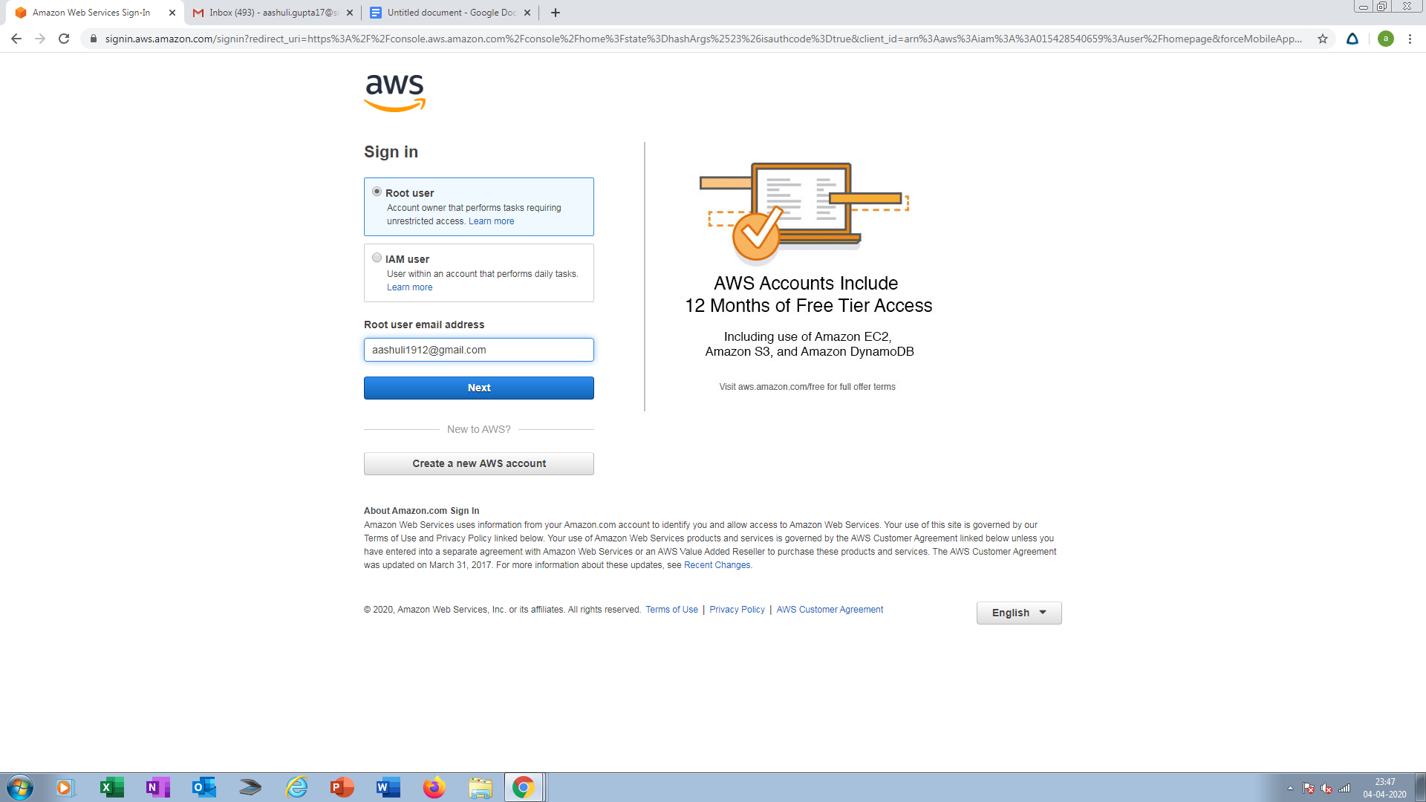

2.EC2 DASHBOARD

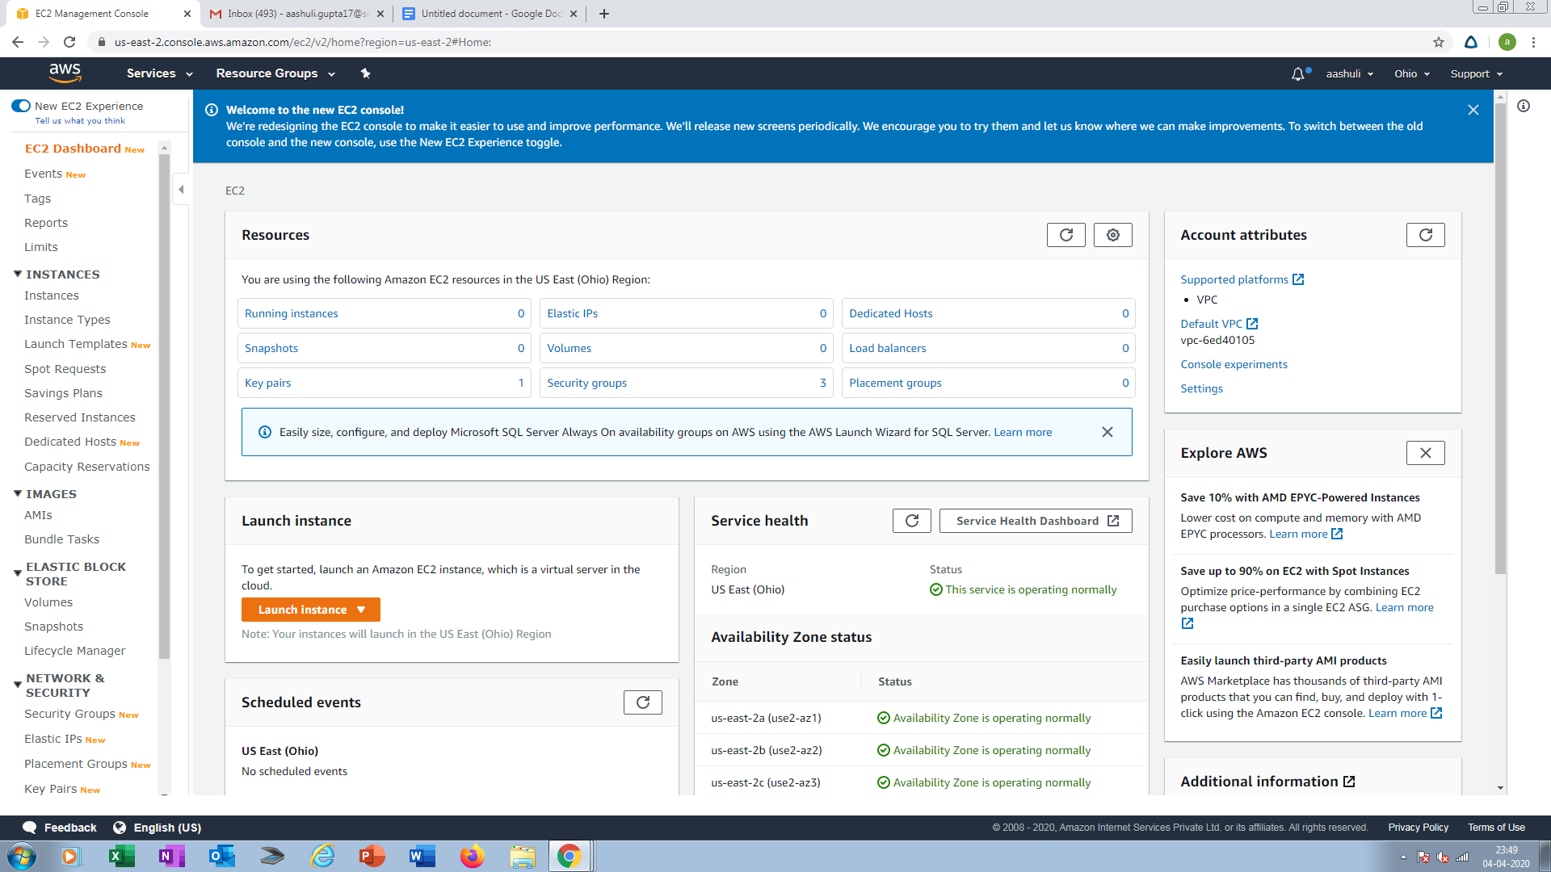

3.S3 DASHBOARD

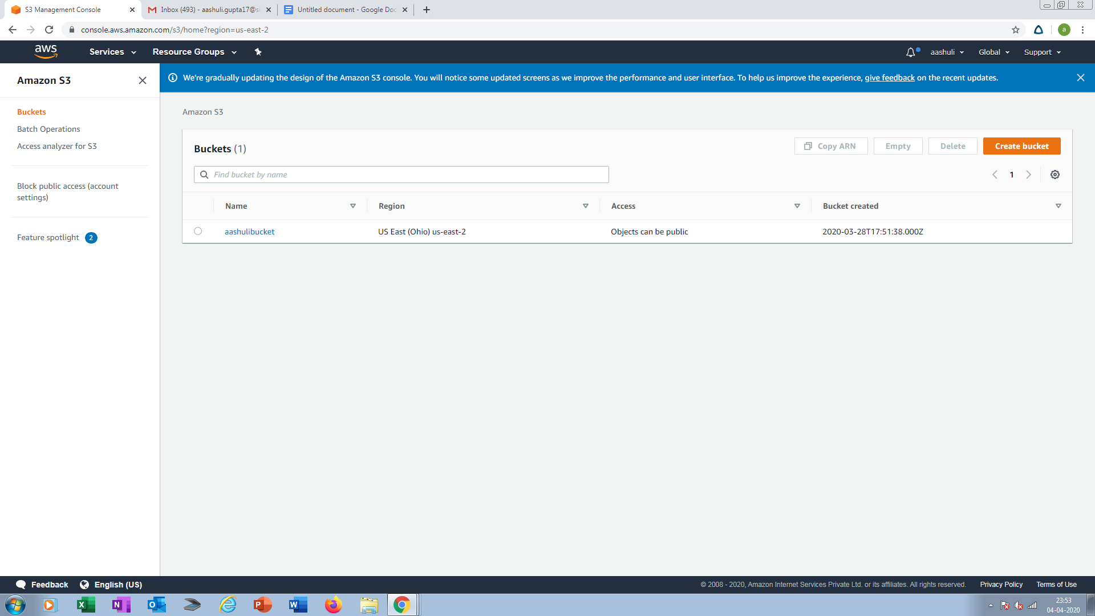

4.REKOGNITION DASHBOARD

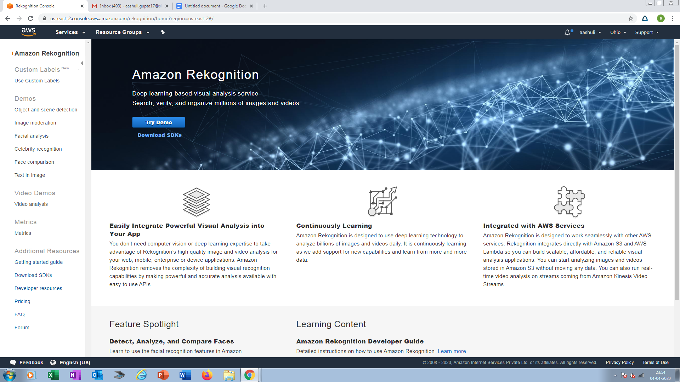

PART2: EC2

5.CHOOSING AN AMI

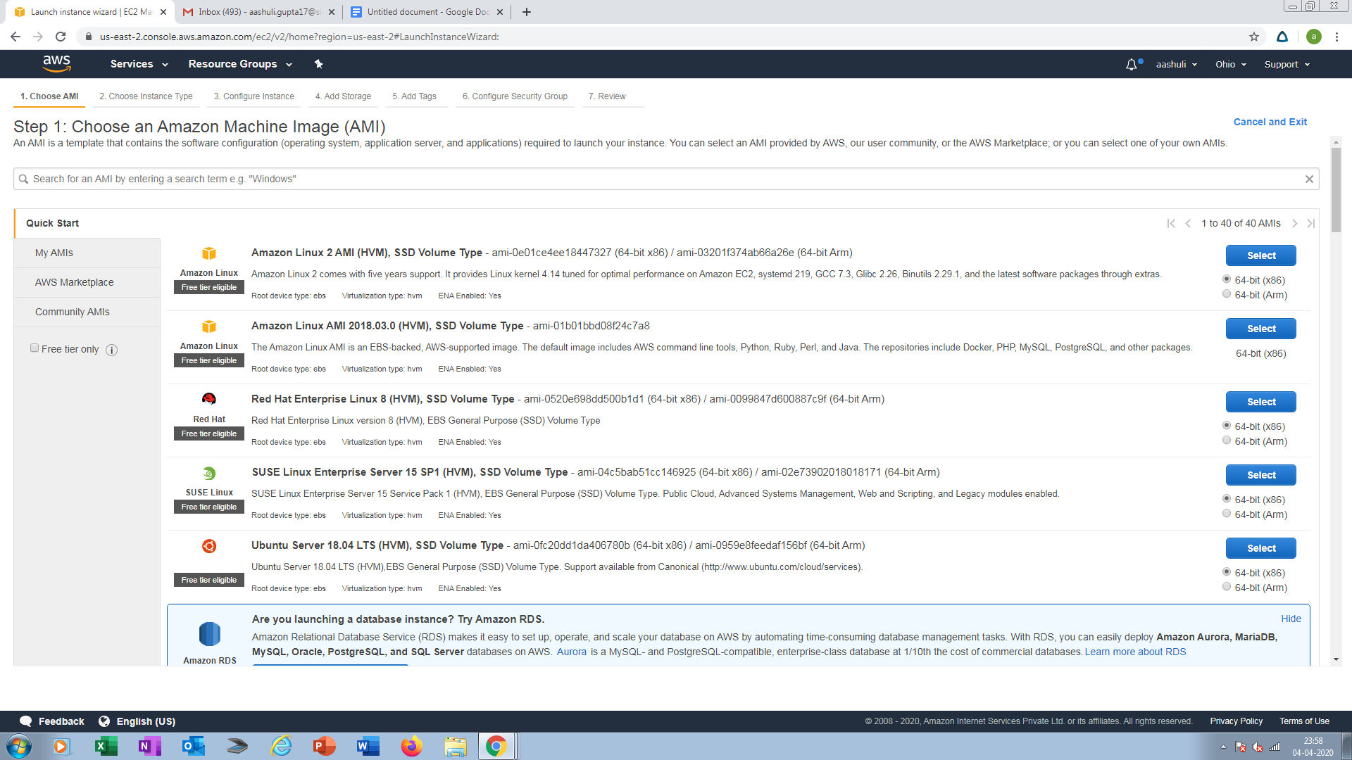

6.CHOOSING AN INSTANCE TYPE

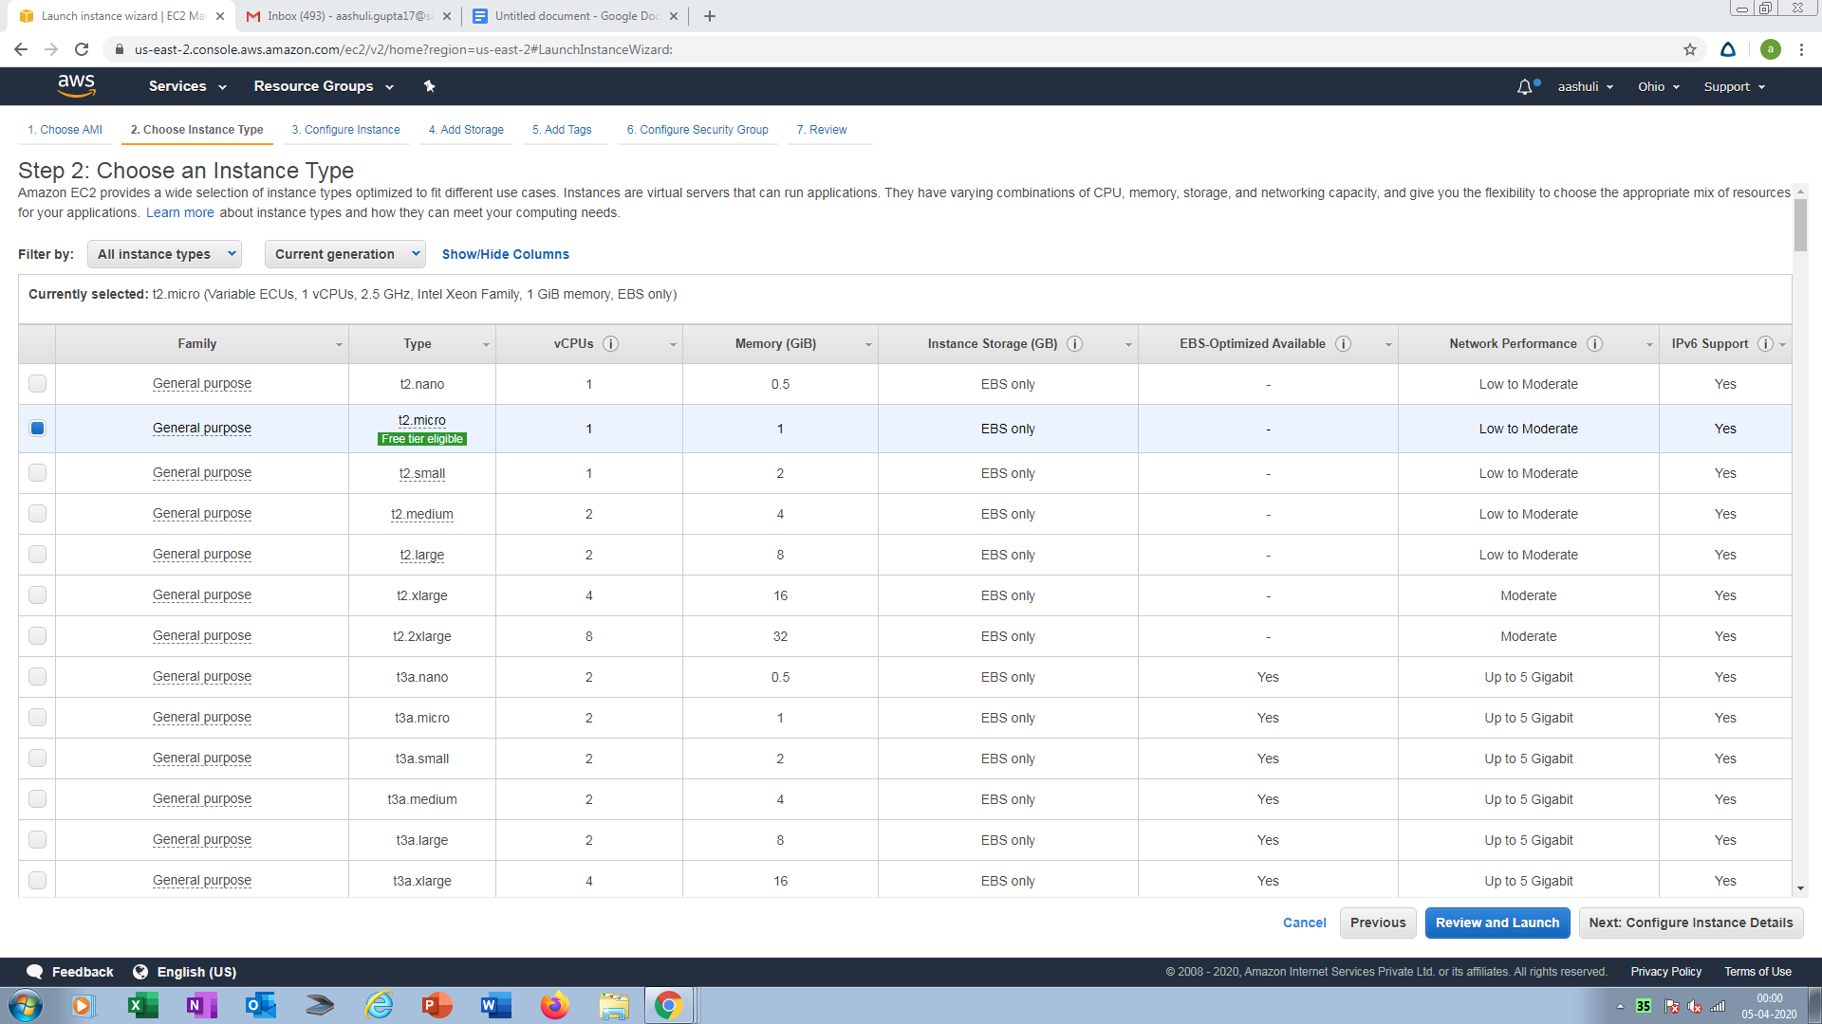

7.ADDING STORAGE

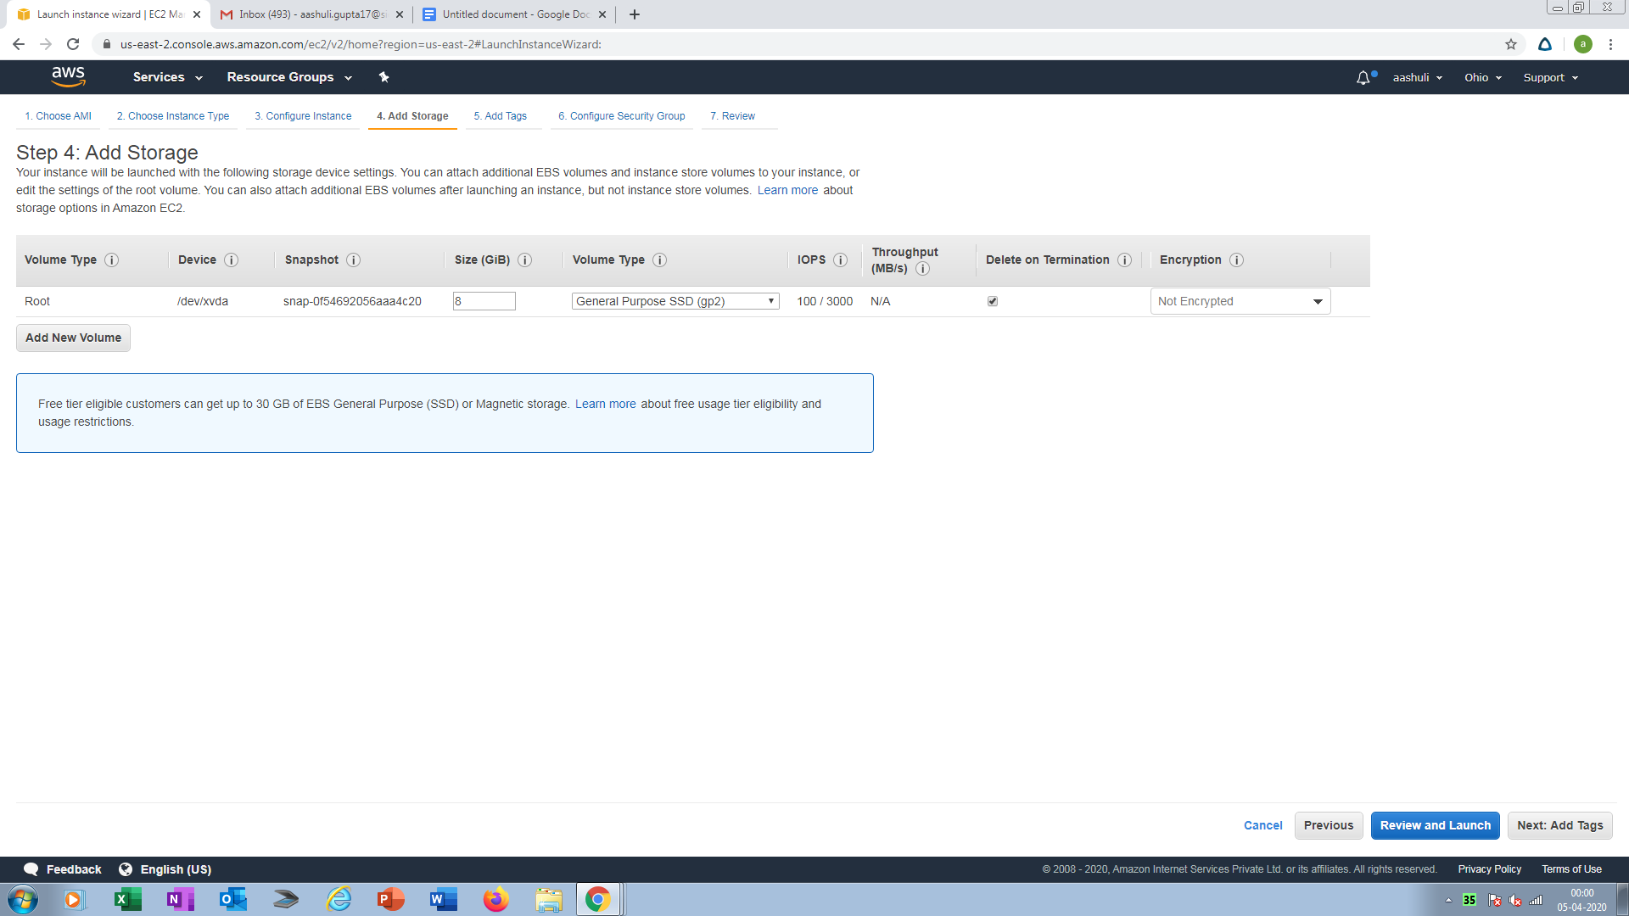

8.CONFIGURING SECURITY TYPE

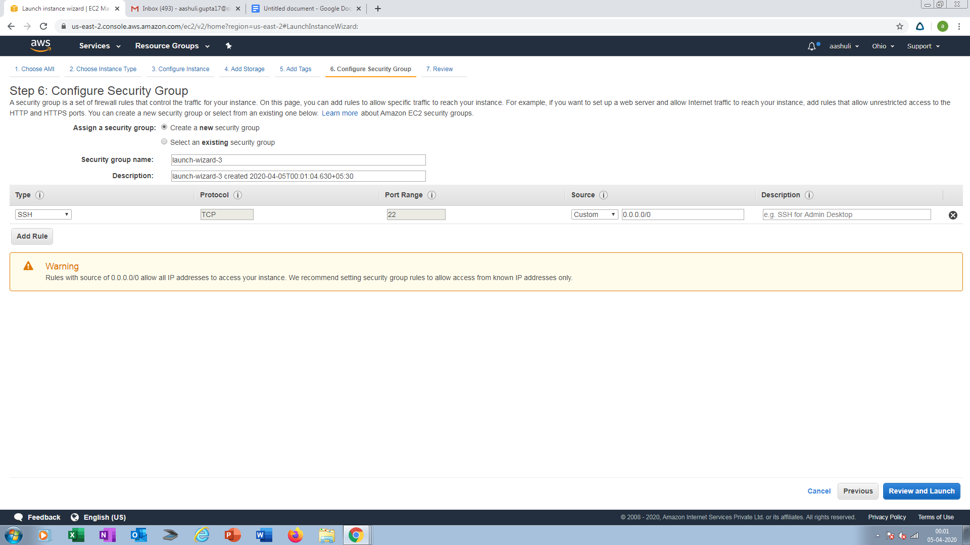

9.KEY PAIR DOWNLOAD

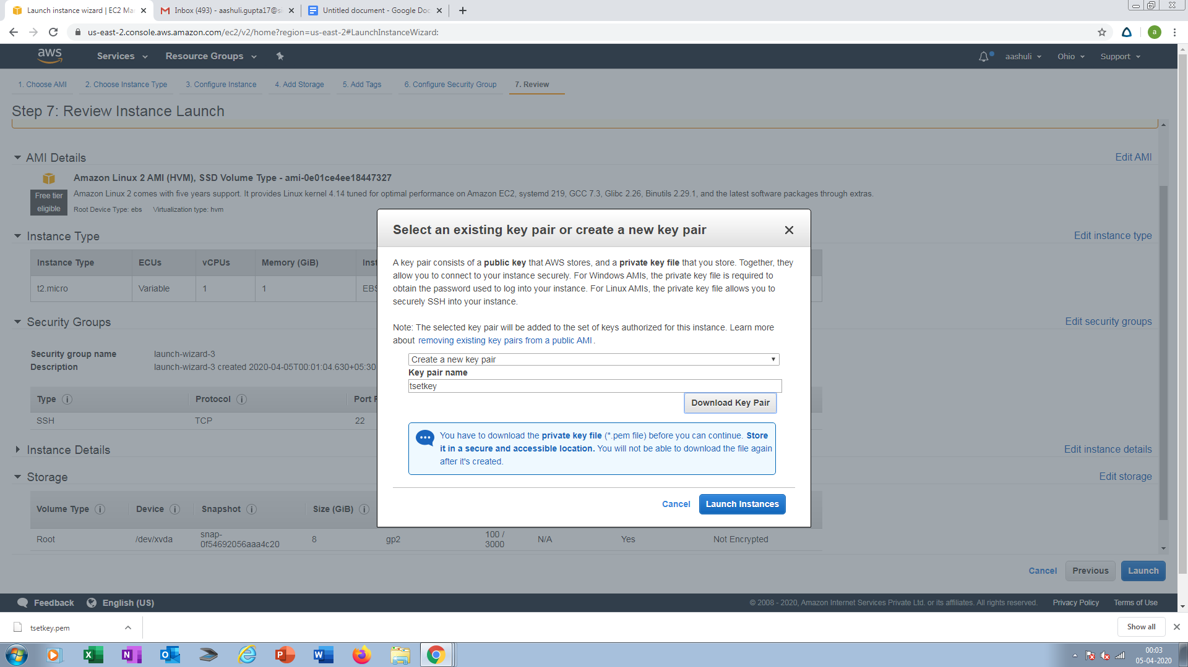

10.PUTTYGEN CONVERSION FROM PEM TO PPK

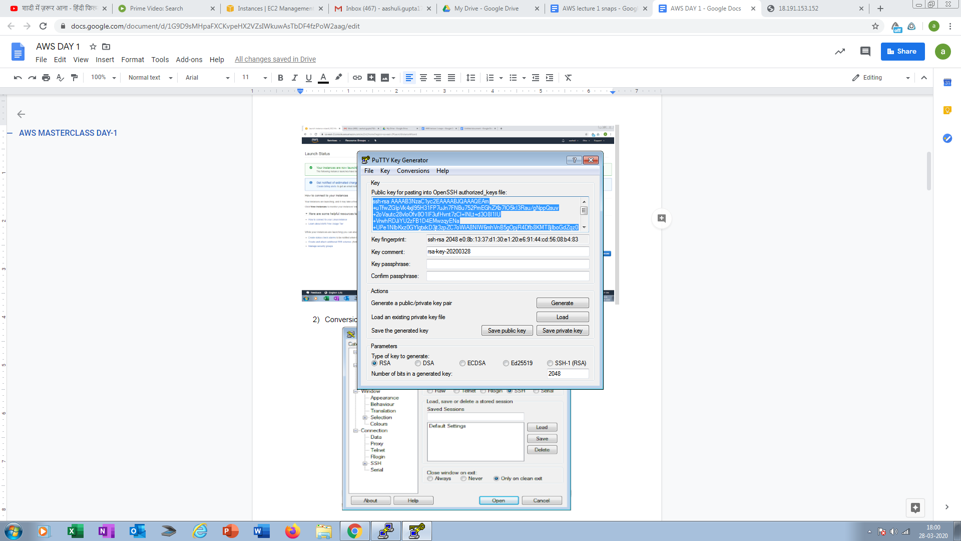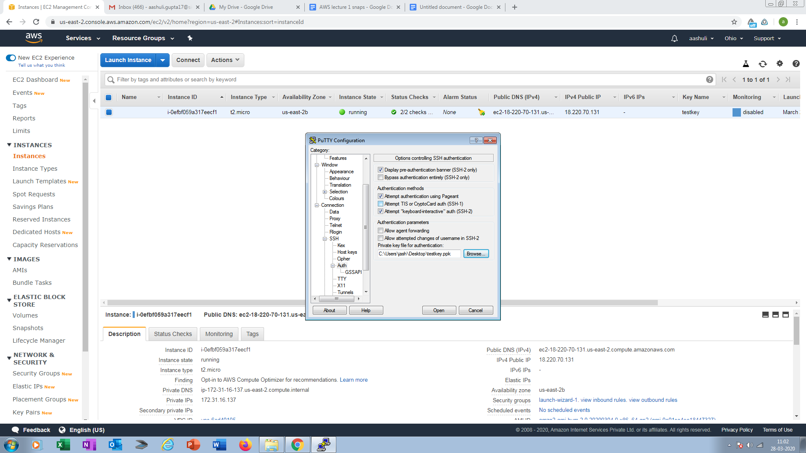

11.LOGGED IN EC2 BLACK SCREEN

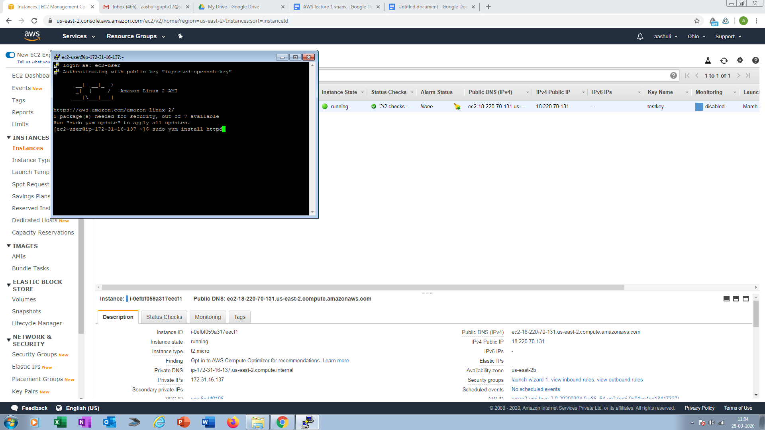

PART3: S3

12.CREATING A BUCKET

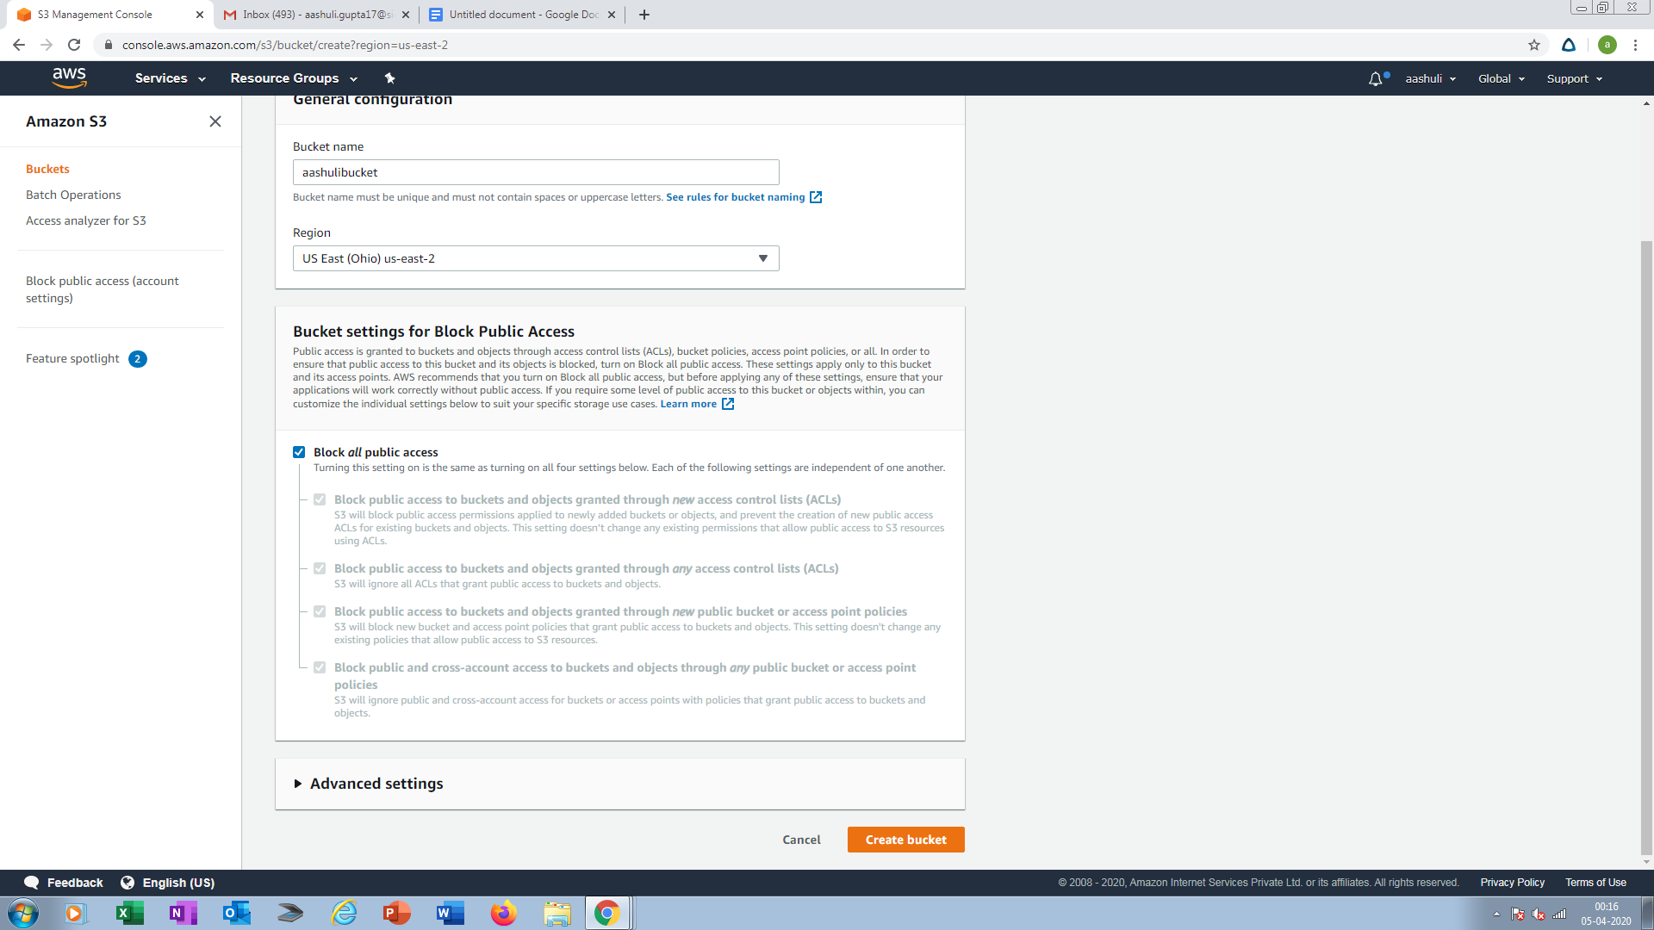

13.UPLOADING AN OBJECT

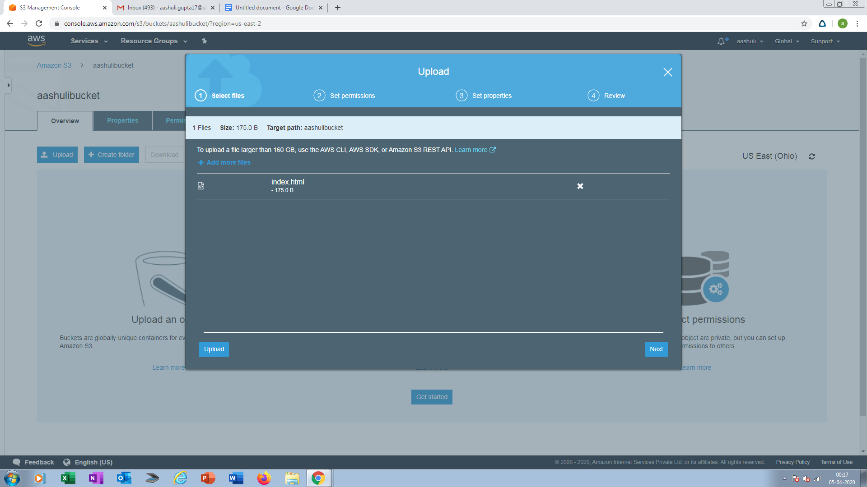

14.ENABLING THE STATIC WEBSITE

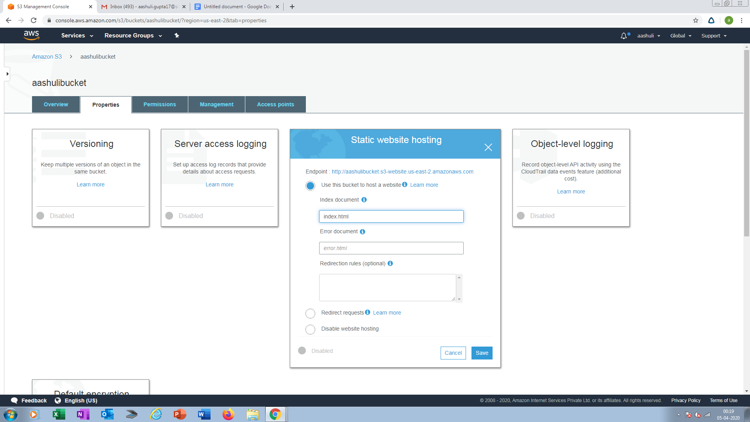

15.MAKING THE OBJECT PUBLIC

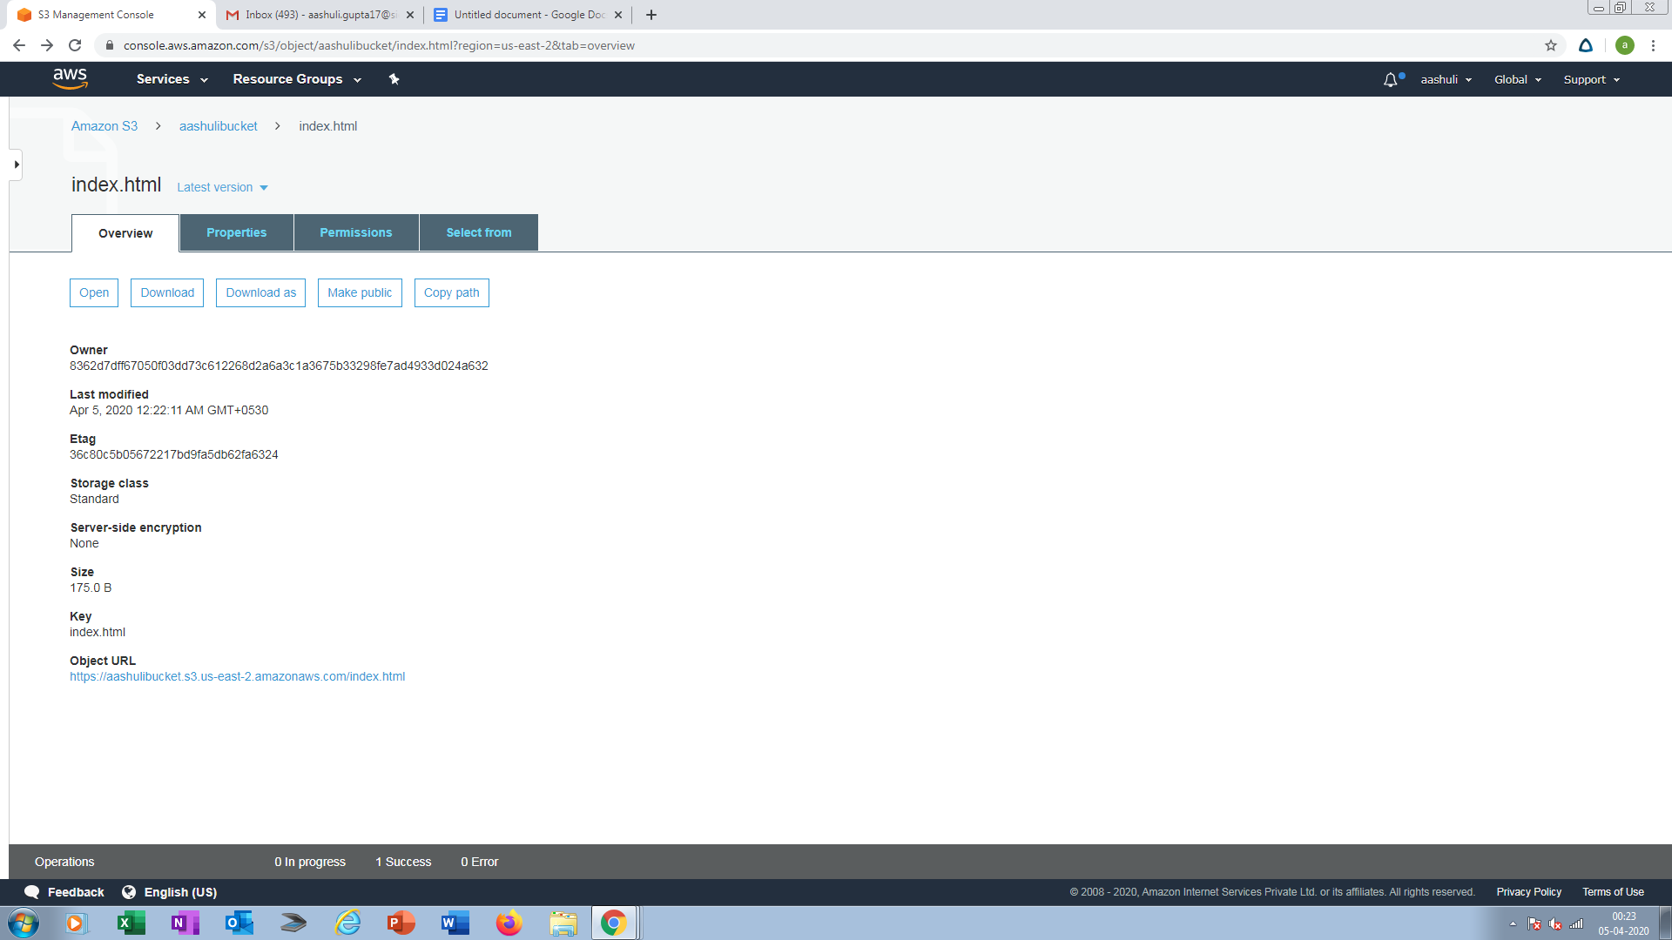

16.CHECKING THE S3 LINK ON BROWSER

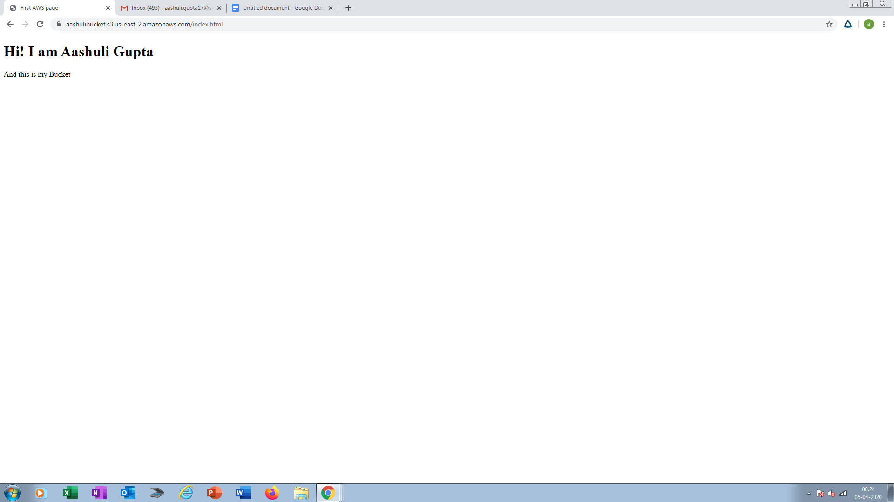

PART4: REKOGNITION

17.FACE DETECT

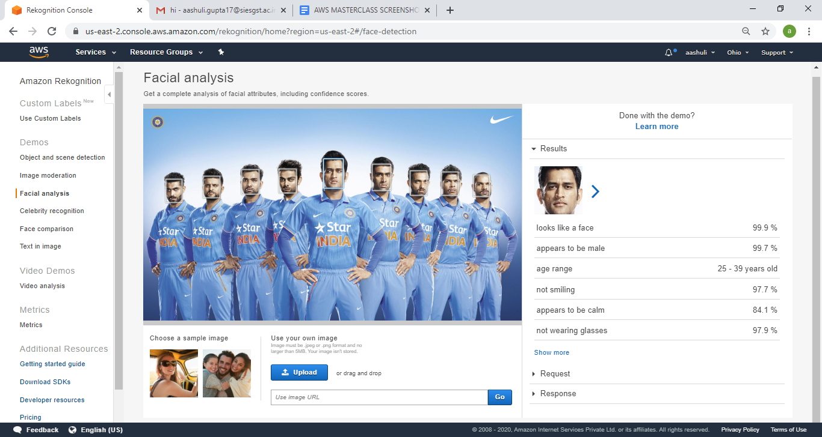

18. FACE COMPARE

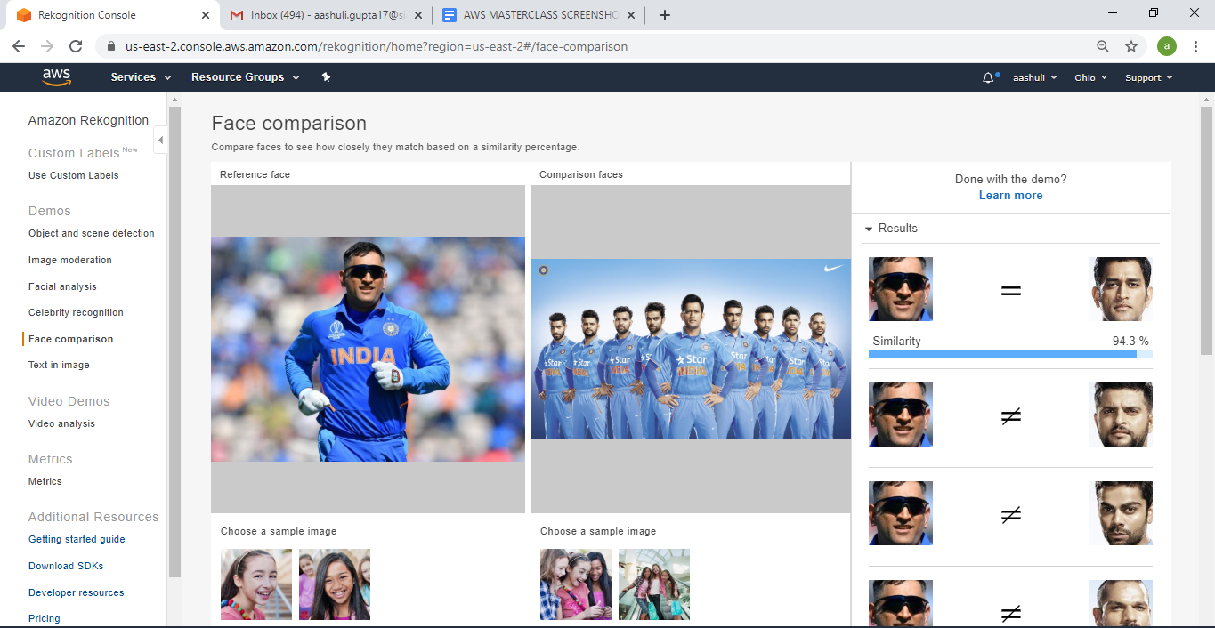

19.CELEBRITY REKOGNITION

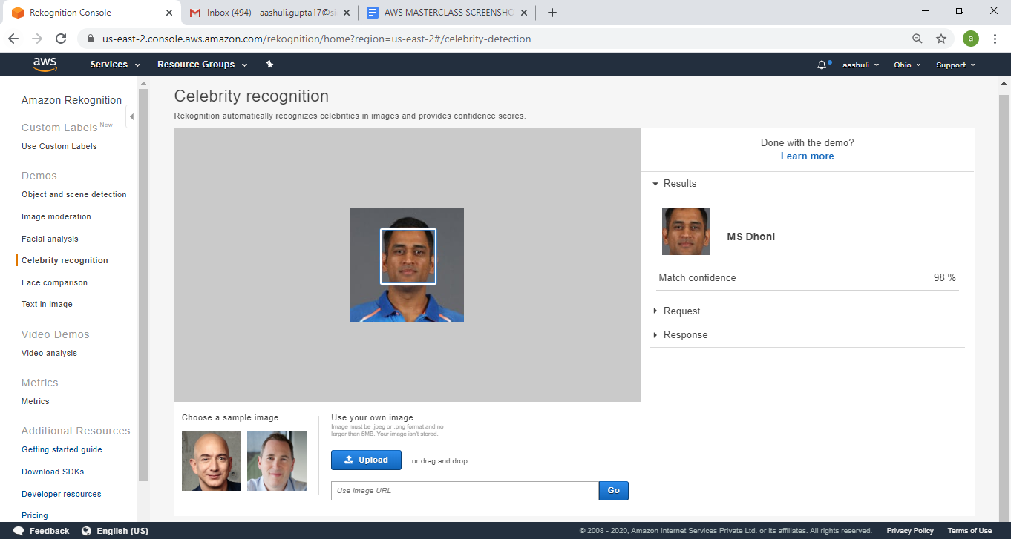

20. TEXT IN IMAGE

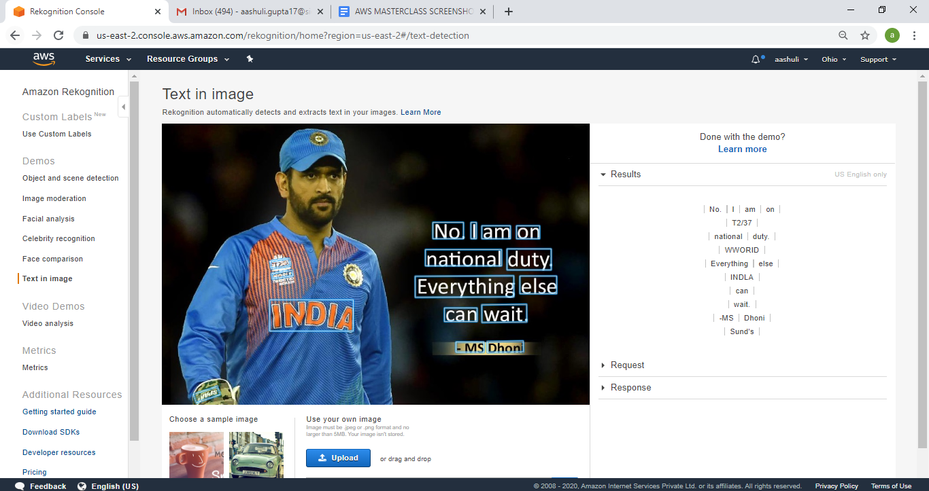

PART5: EC2 AND S3

21. INSTALLING AWS-SDK

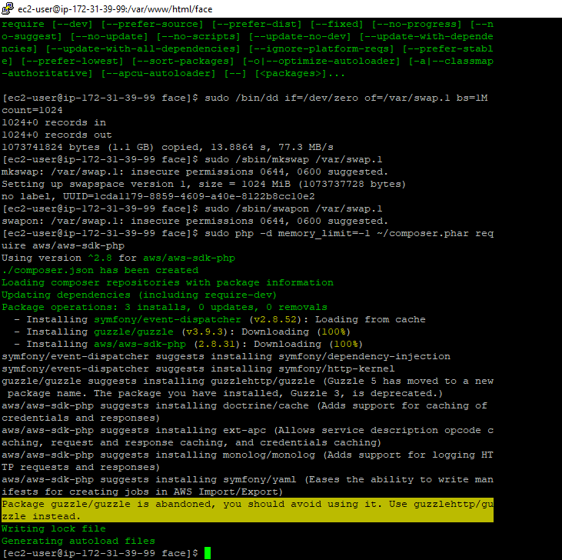

22.INSTALLING PHP

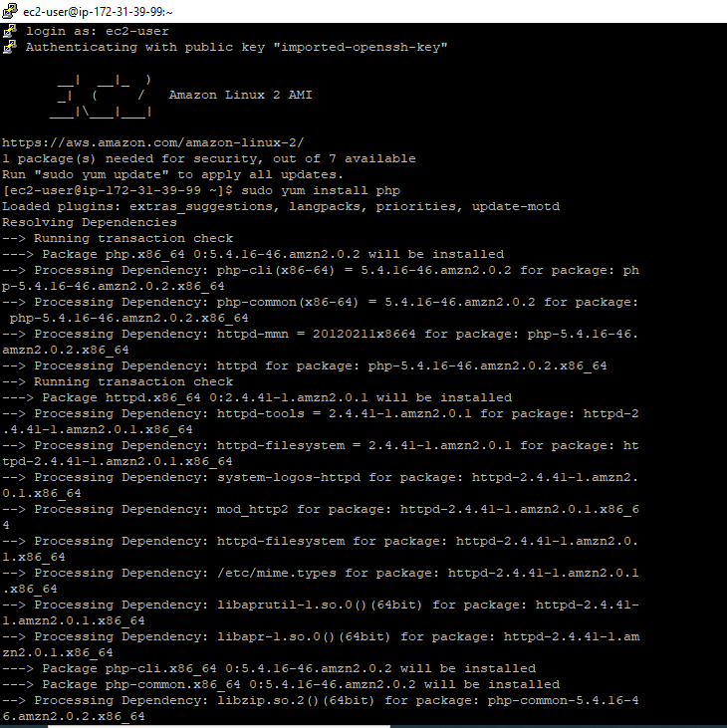

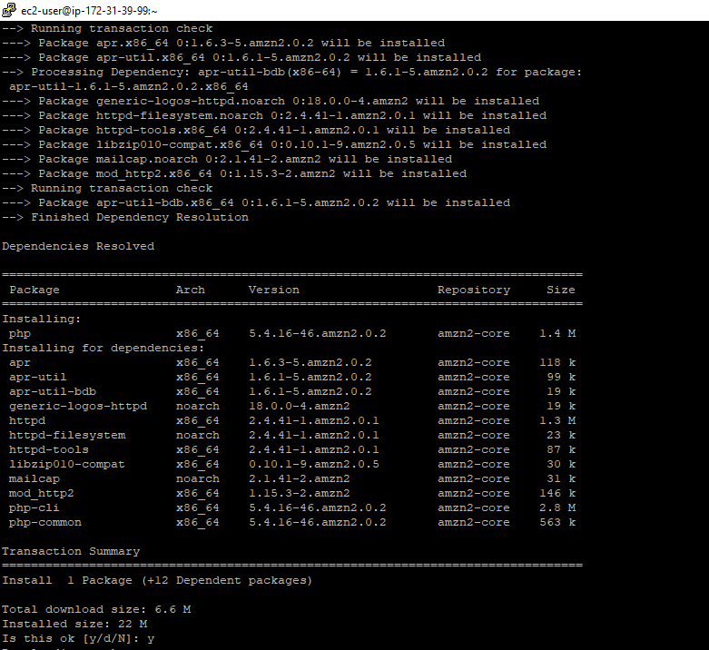

23.index.php FILE CODE

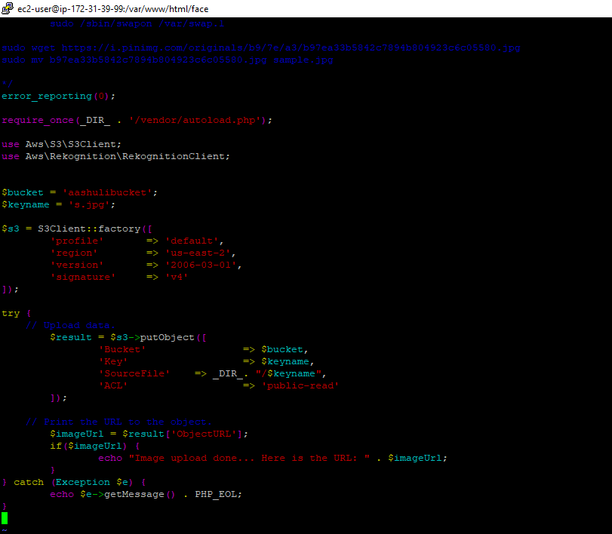

24.UPLOAD SUCCESS SCREENSHOT

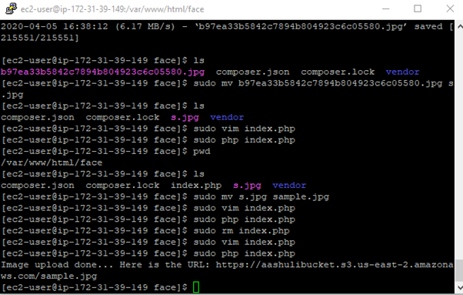

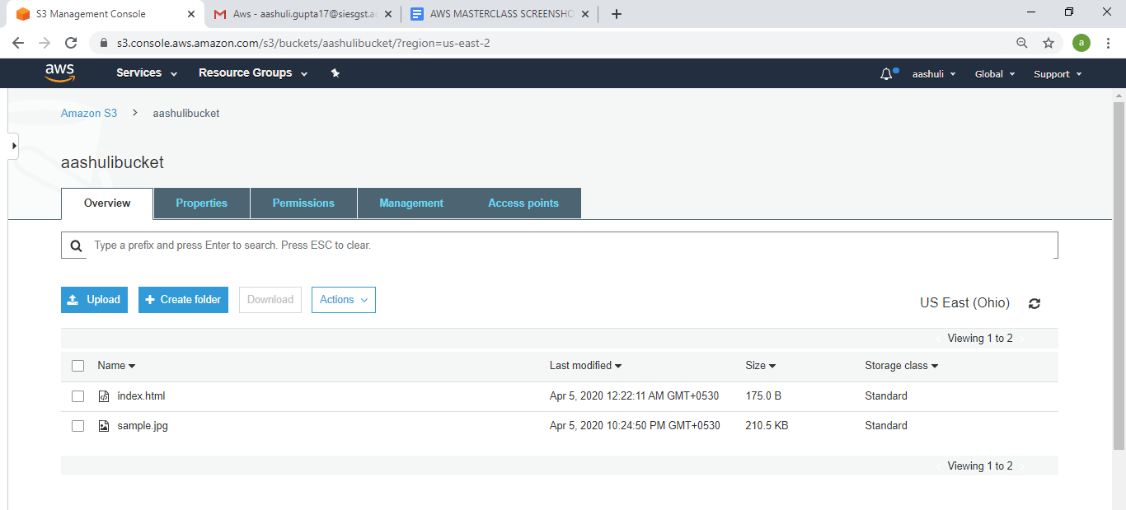

EC2 & REKOGNITION

25.FACE DETECT SUCCESS SCREENSHOT

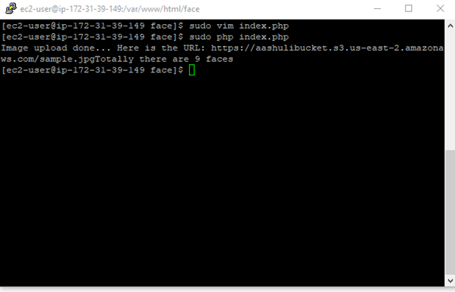\

Input image:

